

**Software Project 1 Report**

**GROUP NAME:** **Bazar-Ghat**

**GROUP MEMBER:**

|  |  |
| --- | --- |
| **Name** | **ID** |
| **Sayem Ahmmed** | **212-15-14738** |
| **Zarrin Tasnim** | **212-15-14740** |
| **Rayhan Rafin** | **212-15-14715** |
| **Muntasir Chowdhury** | **212-15-14737** |

**SUBMITTED TO:**

**Md. Hafizur Rahman Arfin**

**Daffodil International University**

**Project name: Bazar-Ghat**

**Short Description:** Bazar-Ghat is such an app which will bring all the grocery shop next to you. Search and discover in a short time, you can buy your products. Download the Bazar-Ghat app for free and use it across all your devices. Create a shopping list right now and start planning your shopping with others!

WHY Bazar-Ghat?  
❗️ The easiest shopping list app to share with multiple people  
❗️ Save your cards in your wallet in Bring!

**Frontend:**  We used figma to complete our frontend. We try to give a user-friendly and easy to use.

**Backend:** Work of API’s is given bellow:

**GET**= The **GET method** is used to retrieve data from the server.

**POST**= The **POST method** sends data to the server and creates a new resource.

**PUT**= The **PUT method** is most often used to update an existing resource.

**DELETE**= The **DELETE method** is used to delete a resource specified by its URI.

Our application’s backend design:

**(i)/order:** If user fills up and submit informations of order page then it ‘ll be a get request as the user is giving his/her information.



**(ii)/offers:** If a user clicks on an offers option then it ‘ll return a list of offers. As using is watching the offers list so, it's a GET request.



**(iii)/orderproduct/order:** As the user is giving order product,it’s a POST request.



**(iv)/orderID:** As the user is requesting to order ID, it's a GET request.



**(v)/profile:** As the user is requesting to update his/her profile, so it’s a PUT request.



**(vi)/delete/order/orderID:** As the user is requesting for deleting his/her order, so it’s a DELETE request.



**(vii)/profile/phone:** As the user is requesting for update his/her phone number, so it’s a PUT request.



**(viii)/delete/profile/mobile:** As the user is requesting for deleting his/her mobile number, so it’s a DELETE request.

**Database:**

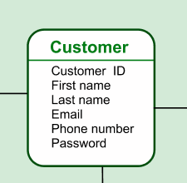**Table 1:**  Here we store customer’s information. Customer id, email is primary key

**Table 2:** Here customer id and order id is primary key and product name is foreign key.

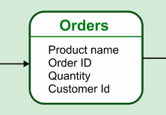

**Table 3:** This table is for payment methods. User can choose credit Card, debit card or others options to complete payment process.

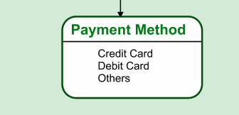

**Table 4:** This table represents necessary information for service. We need to know the location of the place. Also, we need to know customer id, offer code and quantity.

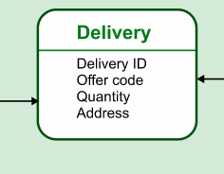

**Table 5:** In this table we use offer code and product .

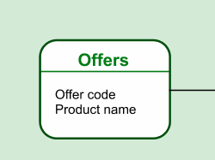

**Relation Between Tables:** One customer can have multiple orders, payment methods. That’s why the relation between “Customer table” & “payment table” is one to many.The relation between “customer table” and “orders table” is one to many. The relation between “orders” and “delivery table” is one to one. The relation between “delivery table” and “offers table” is many to many.

